Deployment:
Kubernetes offers several deployment strategies to manage the rollout and update of applications with different characteristics and requirements. Each strategy has its advantages and use cases. Here are some common Kubernetes deployment strategies:
RollingUpdate Deployment:

RollingUpdate Deployment:
- Description: This is the default deployment strategy in Kubernetes.
- How It Works: It gradually replaces old Pods with new ones, ensuring that a specified number of Pods are available throughout the update.
- Use Cases: Suitable for stateless applications that can handle multiple versions running concurrently. Provides zero-downtime updates.
- Example: See the previous response for an example.

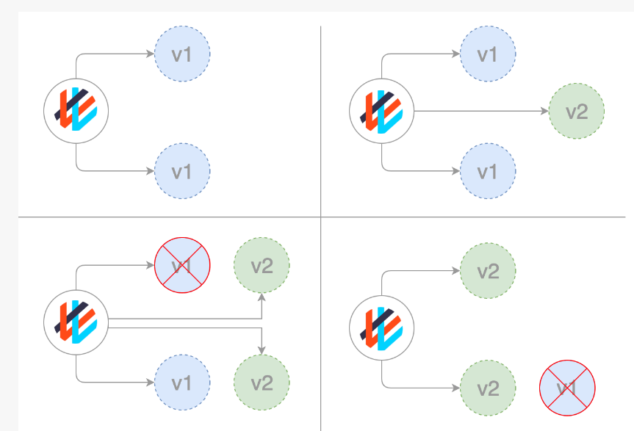

apiVersion: apps/v1
kind: Deployment
metadata:
name: nginx-deployment1
spec:
replicas: 3
selector:
matchLabels:
app: nginx
template:
metadata:
labels:
app: nginx
spec:
containers:
- name: nginx-container
image: nginx:1.20 # Initial Nginx version
ports:
- containerPort: 80
minReadySeconds: 10
strategy:
type: RollingUpdate # Specify RollingUpdate strategy
rollingUpdate:
maxUnavailable: 1 # Number of unavailable Pods during update
maxSurge: 1 # Number of additional Pods that can be created during update
# Define labels to be used for selecting Pods during update
selector:
matchLabels:
app: nginx

Recreate Deployment:

Recreate Deployment:
- Description: This strategy terminates all old Pods before creating new ones.
- How It Works: Deletes all old Pods and then creates new Pods with updated configurations.
- Use Cases: Useful when you want to ensure a clean slate and don't need to maintain old Pods during updates. Typically used for stateless applications.
- Example: In a Deployment manifest, set the strategy type to Recreate.

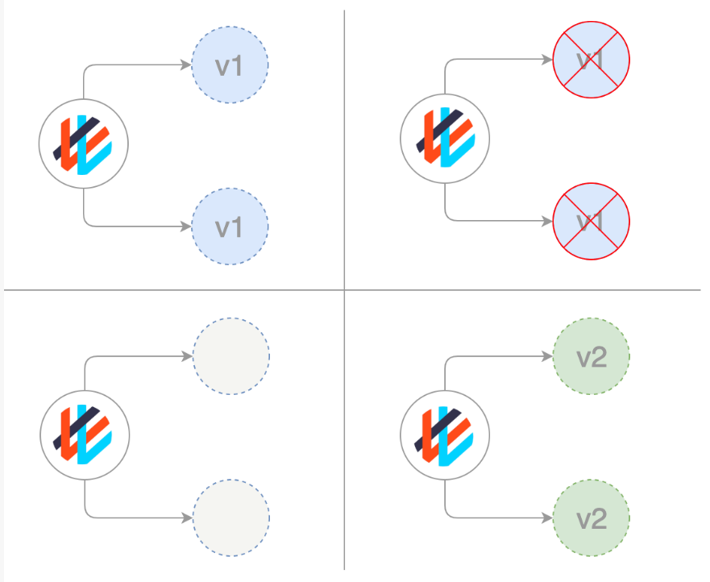

Blue-Green Deployment:
- Description: Involves running two identical environments (blue and green) and switching traffic from one environment to the other during updates.
- How It Works: Initially, one environment (e.g., blue) serves traffic. The updated version (e.g., green) is deployed alongside it. Once the green environment is ready, traffic is switched from blue to green.
- Use Cases: Provides a safe way to test updates or new features before exposing them to all users. Commonly used in production environments.
- Example: Typically implemented using Ingress Controllers or service routing.

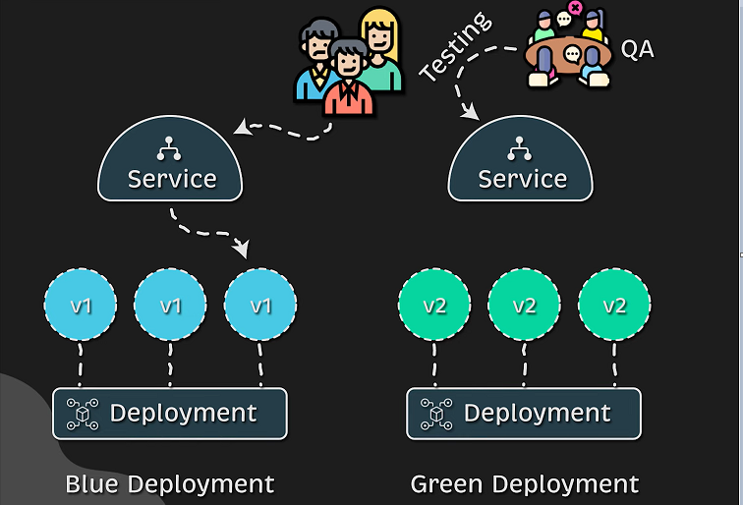

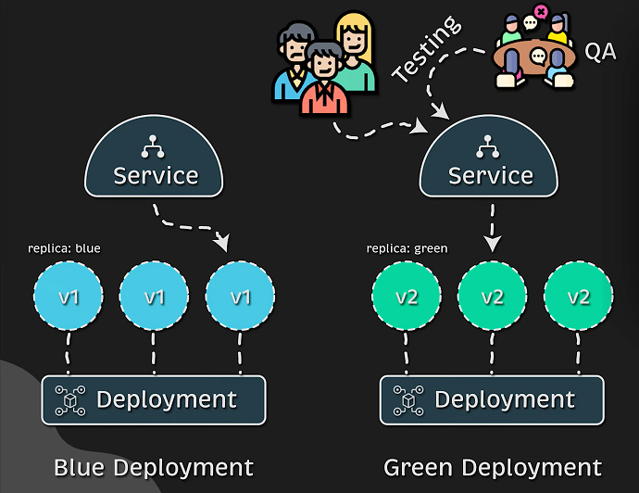

Canary Deployment:
- Description: Gradually introduces a new version of an application to a subset of users or traffic.
- How It Works: Initially, a small portion of traffic is routed to the updated version while the majority still goes to the old version. Over time, the ratio is adjusted.
- Use Cases: Useful for testing new features or updates with a small subset of users before rolling them out to the entire user base.
- Example: Implement using service routing and traffic splitting techniques.

